2018

Sandwell SENCo Steering Group

Inclusion Support

2018

Sandwell Skills Ladders

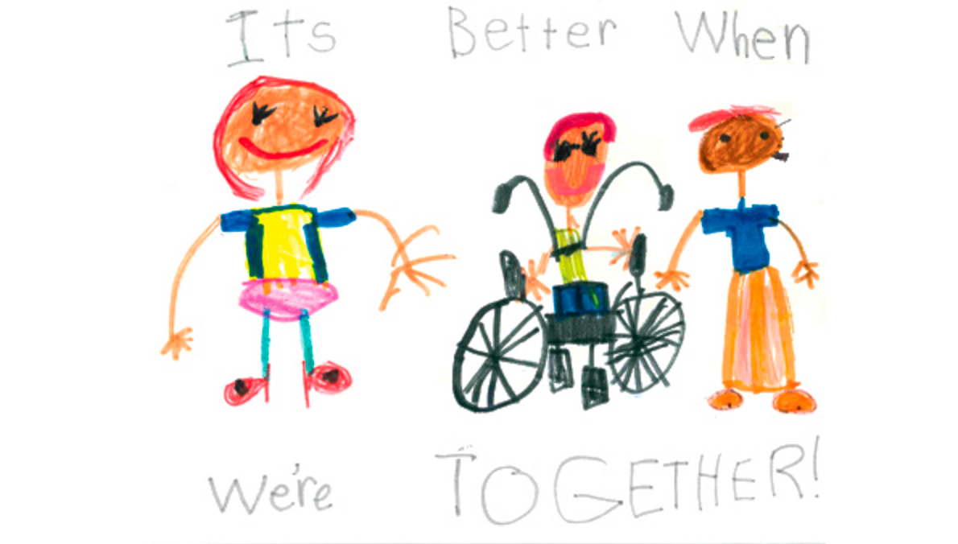

Sandwell Skills Ladders

Introduction

Following the recommendation of the Rochford Review to remove the P Scales in 2018/2019, Sandwell SENCos wanted a consistent approach to assessing pupils who are working below Yr. 1 curriculum. The rationale behind the Sandwell Skills Ladders was to provide Sandwell schools with a common language and assessment framework that could be used throughout the borough. This shared approach to assessment would aid schools in moderating and sharing good practice in helping pupils with SEND to progress.

Sandwell Skills Ladders covers basic skills in Reading, Writing and Maths. Each subject area has 4 stages: Building concepts, Early 1, Early 2 and Early 3. The skills within the Early 3 stage should then lead onto the skills taught in the Yr. 1 curriculum.

Each stage is divided into a number of skills that are written as “I can” statements. The statements are then sub-divided into different levels: emerging, developing and secure, which are dependent on the amount of support the pupil receives. This provides opportunities for the pupil to show both linear and lateral progress across the learning ladders.

Not every “I can” statement has to be met in order to progress to the next stage. The Learning Ladders use a best fit approach, which provides a level of flexibility. However, each stage has a number of “Key Performance Indicators” (KPIs) which should be achieved before progressing onto the next stage. The KPIs are seen as vital steps that need to secure before moving on with the next steps in learning. KPIs are also linked to the current pre-key stage standards that are used for reporting attainment at the end of KS1 and KS2. KPIs are marked in green on the skills ladders.

Guidance

**Defining Emerging, Developing, Secure**

* Emerging: Just beginning to learn the skill. This could be through direct physical prompts such as hand over hand, direct adult modelling.
* Developing: Pupil is not yet consistent with skill. Adult supports through verbal prompting / modelling (pupil independently applies the skill for 50% of the time)
* Secure: Pupil can independently apply the skill for more than 80% of the time. They can transfer the skill in a variety of contexts (environment, situation, interacting with different adults)

**Qualifiers and examples**

Some of the “I can” statements within the skills ladders contain qualifiers: ‘some’, ‘many’ and ‘most’ to indicate the extent to which pupils should demonstrate the knowledge or skill required. Where qualifiers are used, they have consistent meaning:

* ‘most’ means that the statement is generally met with only occasional errors
* ‘many’ indicates that the statement is met frequently but not yet consistently
* ‘some’ indicates that the skill/knowledge is starting to be acquired and is demonstrated correctly on occasion, but is not yet consistent or frequent.

Some of the “I can” statements contain examples. These do not dictate the evidence required, but show only how that statement might be met. Teachers should use their own professional judgement in choosing learning activities that allow pupils to demonstrate their level of skill

**Moving to the next stage**

To determine the overall stage that a pupil is working at, the teacher should use a best fit judgement. As a rule of thumb, this would be approximately 80% completion of the “I can” statements in a stage with a quantified amount of support.

For instance: Early Reading 1 (ER1) Emerging

Early Reading 1 (ER1) Developing

Early Reading 1 (ER1) Secure

**Evidence**

Skills should be taught and applied using a variety of methods and resources. The aim is for pupils to transfer skills across the curriculum and learning environments into real life situations. Please be mindful to ensure practical usage of the skill across the entire curriculum.

Teachers need to base their judgements on a broad range of evidence, which will come from day-to-day work in the classroom. This should include work in other curriculum subject areas to the one being assessed, although a pupil’s work in that subject alone may provide sufficient evidence to support the judgement.

Teachers evidence should include observation notes, photos, videos as well as written work. EYFS assessment methods will act as a guide of good practice.

**Accessibility**

Pupils should demonstrate the skills using their preferred method of communication or individual method of learning. For instance, some pupils who will not be able to verbally show their understanding of the skill due to communication difficulties, may be able to demonstrate the skills through the use of signing, visual methods of communication such as PECs, eye gaze. Pupils with physical disabilities who have limited fine motor control could demonstrate skills using a different written medium such as computer, tablet or magnetic letters. Teachers should ensure that all pupils have the opportunity to demonstrate the skill, with reasonable adjustments in place, in an equivalent way.

If a pupil has a Special Educational Need or disability which prevents them from ever being able to complete an “I can” statement, even with reasonable adjustments, then teachers should use their own professionalism (in consultation with SENCO) to exempt the pupil. This might apply to skills around handwriting for pupils with physical difficulties or phonics for hearing impaired children who have not been taught visual phonics.

Acknowledgments

Thank you to all the SENCos/colleagues who gave time to contribute to this project:

Stuart Gough – Brandhall Primary

Charlene Degg – Causeway Green Primary

Eve Jones – Christ Church CE Primary

Patricia Parkes -Christ Church CE Primary

Sarah Bamber – Crocketts Community Primary

Beth Barnsley – Devonshire Infant/Junior Academy

Hayley Edwards – Grace Mary Primary

Laura Willetts – Grace Mary Primary

Claire Exall – Hanbury Primary

Sorrell Winsper – Galton Valley Primary

Richard Hipkiss – Hargate Primary

Natalie Dolan – Harvills Hawthorn Primary

Sian Evans – Highfields Primary

Liz Mee – King George V Primary

Laura Payne – Old Park Primary

Sarah Jarass – Old Park Primary

Katie Law – Moat Farm Junior

Barbara Coles – Our Lady’s and St Hubert Catholic Primary

Whitney Plant – Shireland Hall Primary

Stella Highfield – St Mary Magdalene CE Primary

Hayley Lloyd Davies – Summerhill Primary

Yvonne Blakemore – Tameside Primary

Rebecca Fletcher – Tividale Hall Primary

Isabel Dean – Warley Infant

Rebecca Woodhams – Yew Tree Primary

Alice Berry – EYS Inclusion Support

Michelle Duke – Inclusion Support

Diane Lloyd – Inclusion Support

Fiona Patterson – Inclusion Support

Kerrie Hardy – Inclusion Support

Dan Lavell – Inclusion Support